* Write a JavaScript program to count the number of vowels in a given string. Take the input with help of prompt.
* Write a JavaScript program to check whether a given value in textbox is alpha numeric or not.
* Write a JavaScript program to create a puzzle

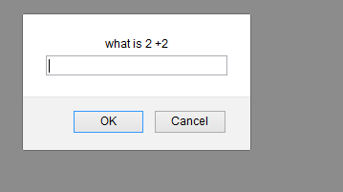

The user has been given 3 chances to solve this puzzle. If answer is correct or user succeeds for first time the then alert should be displayed of winning puzzle. The user can exit also on pressing cancel.

* Write a program for web page attached.
* Write a program for form validation attached image.